

DATA STRUCTURES AND ALGORITHMS

23CSE203
Submitted by
Name | - Chethan venkata deva
Roll No | AV.SC.U4CSE25008
Year/sem/section | ^{2nd} year/sem-3/CSE-A
Credits | 5

Submitted to
Name | DR.RAJKUMAR BATCHU
Department | School of computing
Designation | Asst. professor(SI. Grade)

s.no | title | Pageno | remarks
1 | WEEK 1: 1a. Recursive countdown from n to Launch. 1b. Recursive calculation of compound growth factor. 1c. Recursive search for employee ID in list. 1d. Recursive factorial calculation for parcel arrangements. 1e. Recursive Fibonacci series generation.
2 | WEEK 2: 2a. Write a python program to perform linear search on the give input. 2b. Write a python program to perform binary search on the given. Verify by taking sorted array as an input. 2c. Write a python program to perform binary search on the given. Verify by taking unsorted array as an input.

WEEK-1

1A.AIM:A Rocket launch system displays a countdown before launch. Instead of suing a loop, implement the countdown using recursion. Write a recursive python program to display a countdown from n to 1 followed by “launch”.
Code:
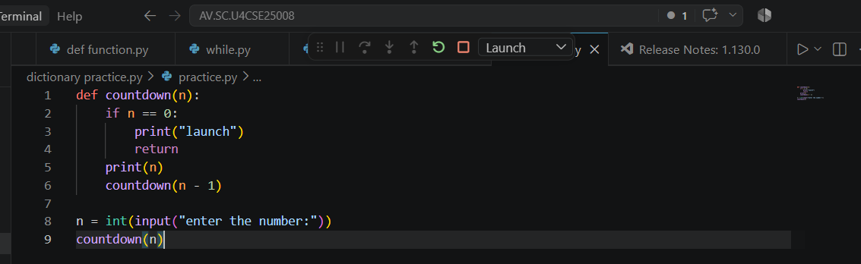
Output:

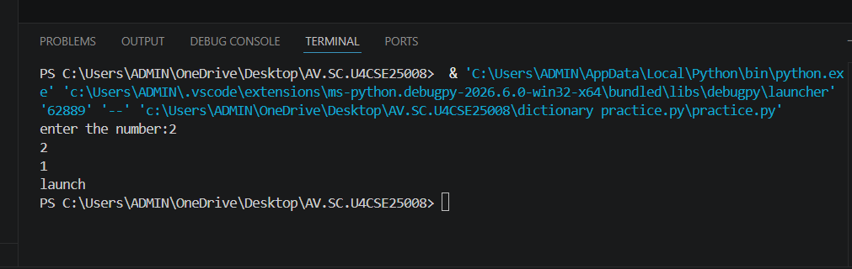
Explanation
Condition 1: Positive Input (n > 0)
- The function checks whether n == 0.
- Since n is positive, the condition is False.
- It executes:
  - print(n) → prints the current value of n.
  - countdown(n-1) → calls the same function again with n-1.
- This process continues until n becomes 0.
- When n == 0, the condition becomes True.
- It prints launch.
- The return statement stops that function call.
- Then the recursive calls return one by one.
- Since there is no value returned by the function, it returns None.
Condition 2: Zero Input (n == 0)
- The function checks if n == 0.
- The condition is immediately True.
- It prints launch.
- The return statement stops the function.
- No recursive call takes place.
- The function returns None.
Condition 3: Negative Input (n < 0)
- The condition n == 0 is False.
- It prints the negative value.
- Then it calls itself with n-1, making the value even more negative.
- Therefore, it will never reach 0.
- The recursion continues indefinitely.
- Eventually, Python raises a RecursionError because the maximum recursion depth is exceeded
s.no | Error obtained | Rectification
1 | Negative input in countdown | Add a condition to handle negative numbers before recursion.

1B. Aim: Banks calculate the growth of an investment using compound interest. The formula requires calculating powers, which can be implemented recursively. Write a recursive program to calculate p(n) where p=principal growth, n= no. of years.
Code:
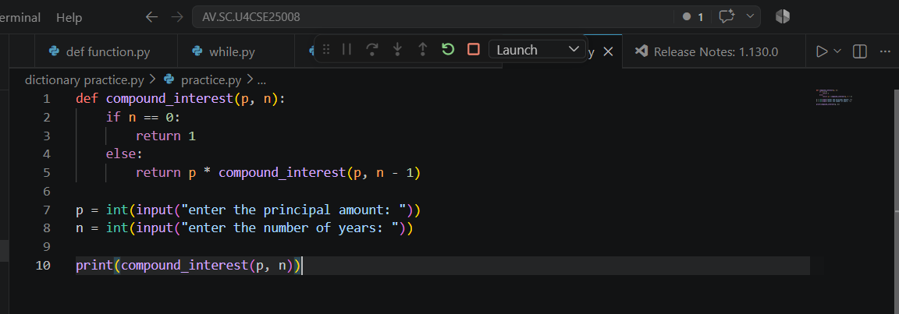
Output:
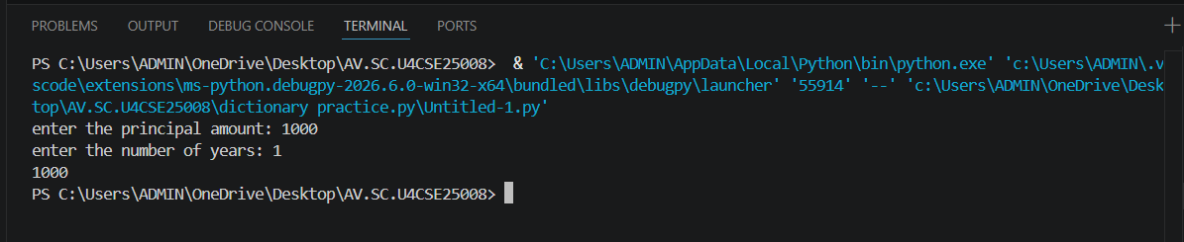

Explanation
Condition 1: n > 0
- The function compound_interest(p, n) is called with the principal amount p and number of years n.
- The function checks whether n == 0.
- Since n is greater than 0, the condition is False.
- It executes the else block.
- It calculates:
  - p * compound_interest(p, n-1)
- The function calls itself recursively with n-1.
- This process continues until n becomes 0.
- Each recursive call multiplies p one more time.
- Therefore, the function calculates pⁿ.
Condition 2: n == 0
- When n becomes 0, the condition n == 0 becomes True.
- The function returns 1.
- This 1 acts as the base case for the multiplication.
- The recursive calls then return one by one.
- Each returned value is multiplied by p.
- Finally, the result is printed using print(compound_interest(p,n))
Error table:
s.no | Error obtained | rectification
1 | Wrong indentation | Maintain proper indentation.

1C. AIM . An Hr department stores employee IDs in a list .Develop a recursive program to search for a given employee ID write a recursive function to search for an employee ID in a list.
Code:
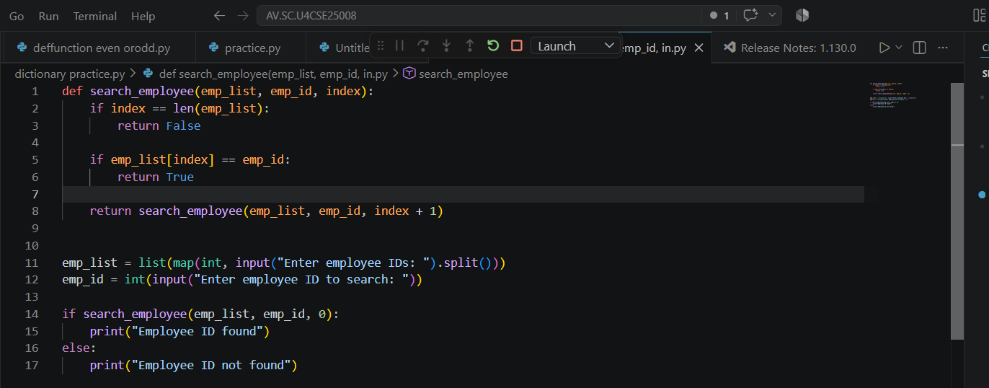
Output:
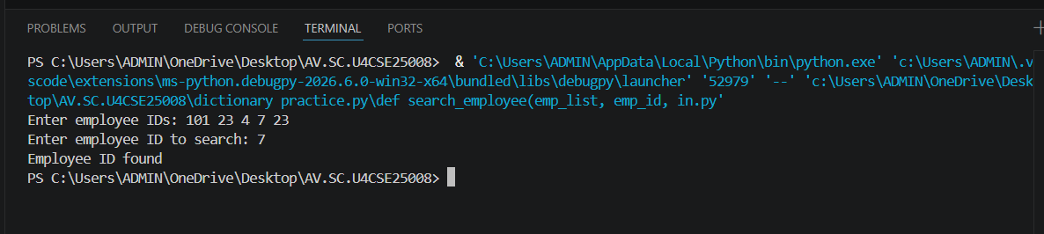
Explanation
Condition 1: index == len(emp_list)
- The function checks whether index has reached the length of the employee list.
- If index == len(emp_list), it means we have checked all employee IDs.
- The employee ID was not found.
- The function returns False.
- No further recursion takes place.
Condition 2: emp_list[index] == emp_id
- The function checks whether the current employee ID is equal to the ID we are searching for.
- If both IDs are equal, the condition becomes True.
- The function returns True.
- The recursion stops because the employee ID has been found.
Condition 3: Employee ID does not match
- If the current employee ID is not equal to emp_id, the condition is False.
- The function calls itself recursively with:
  - index + 1
- This moves to the next employee ID in the list.
- The process continues until:
  - The employee ID is found, or
  - The entire list is checked.
Error table:
s.no | Error obtained | Rectification
1 | Missing return statement | Add the required return statement

1D. AIM. In a logistics company , the no . of possible ways to arrange in different parcels is calculated using the factorial formula (n!). Develop a recursive program to calculate the factorial of a given number.
Code:
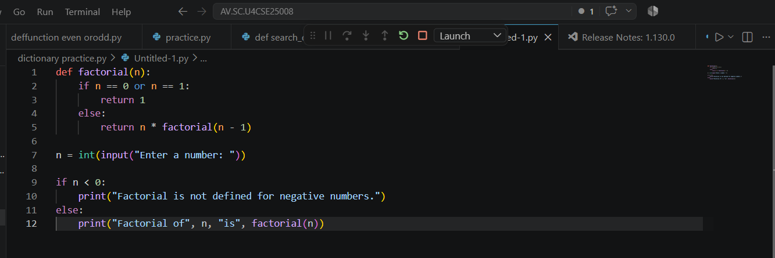
Output:
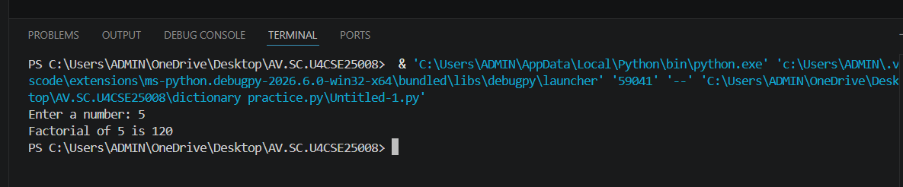
Explanation
Condition 1: Negative Input (n < 0)
- The program first checks whether n < 0.
- If n is negative, the condition is True.
- Factorial is not defined for negative numbers.
- It prints:
Factorial is not defined for negative numbers.
- The factorial() function is not called.
Condition 2: Base Case (n == 0 or n == 1)
- Inside the factorial() function, it checks:
n == 0 or n == 1
- If n is 0 or 1, the condition is True.
- The function returns 1.
- This is the base case of the recursion.
- It stops further recursive calls.
Condition 3: n > 1
- If n is greater than 1, the condition n == 0 or n == 1 is False.
- The else block is executed.
- It returns:
n * factorial(n - 1)
- The function calls itself with n - 1.
- This continues until n becomes 1.
- Then the returned values are multiplied together
Error table:
s.no | Error obtained | Rectification
1 | Wrong recursive value | Updated the recursive value correctly

1E. AIM. Write a recursive program to print the first n terms of the fibonacci series
Code:
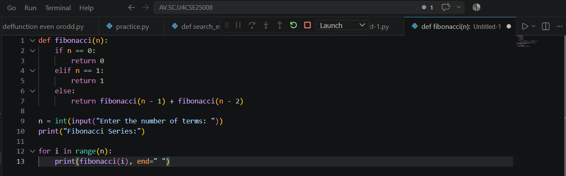
Output:
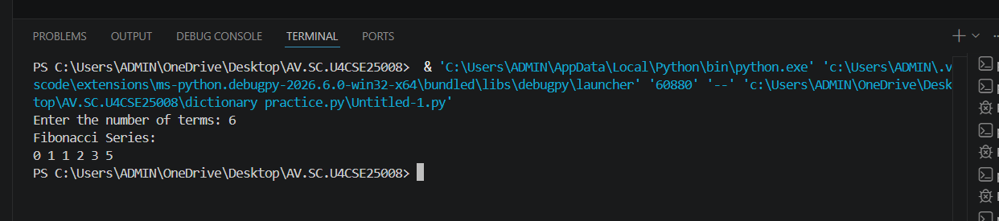
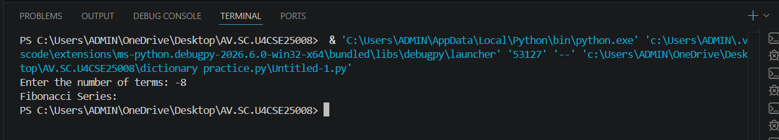
Explanation
Condition 1: n == 0
- The function checks whether n == 0.
- If the condition is True, the function returns 0.
- This is the first base case.
- No further recursive call takes place.
Condition 2: n == 1
- If n is not 0, the function checks whether n == 1.
- If the condition is True, the function returns 1.
- This is the second base case.
- No further recursive call takes place
Condition 3: n > 1
- If n is neither 0 nor 1, both conditions are False.
- The else block is executed.
- The function calls itself two times:
  - fibonacci(n - 1)
  - fibonacci(n - 2)
- The two returned values are added together.
- This process continues until the base cases n == 0 and n == 1 are reached.
Error table:
s.no | Error obtained | Rectification
1 | Incorrect Fibonacci recursion | Use fibonacci(n-1) + fibonacci(n-2).

Week-2
2a. AIM: Write a python program to perform linear search on the give input.
Code:
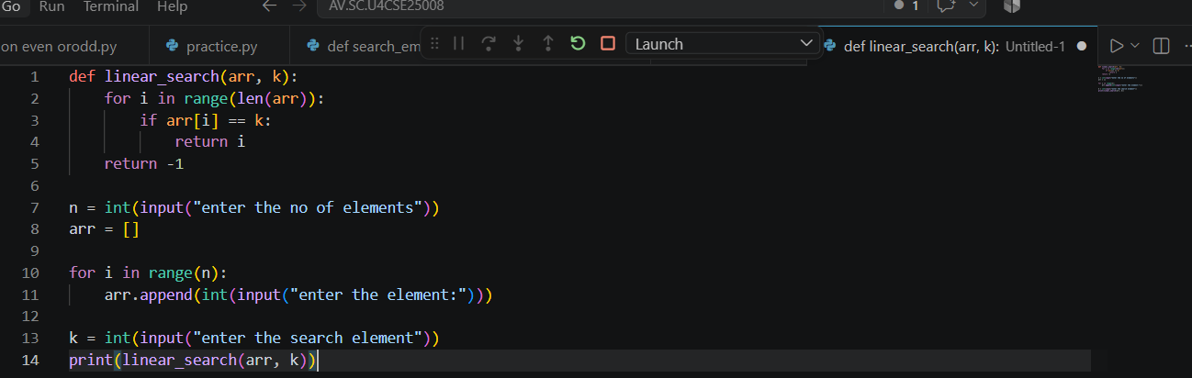
Output:
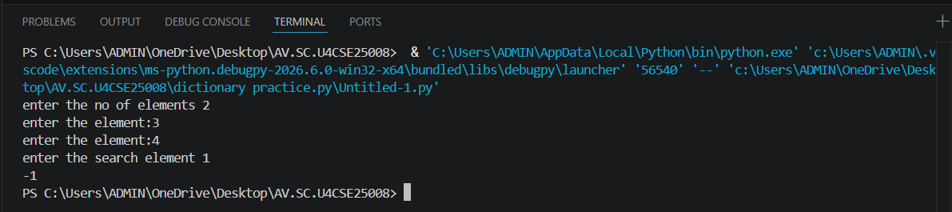
Explanation
Condition 1: Element is Found (arr[i] == k)
- The function linear_search(arr, k) receives the array arr and the search element k.
- The for loop starts from the first element of the array.
- It checks each element one by one using:
arr[i] == k
- If the current element is equal to k, the condition becomes True.
- The function immediately returns the index i.
- Since the function returns the index, the loop stops immediately.
- The remaining elements are not checked.
Condition 2: Element is Not Found
- The loop checks every element in the array.
- If none of the elements is equal to k, the if condition is always False.
- After the loop finishes, the statement return -1 is executed.
- -1 indicates that the search element is not present in the array.
Error table:
s.no | Error obtained | Rectification
1 | Wrong loop range | Use range(n) to process exactly n elements.

2b. AIM: Write a python program to perform binary search on the given. Verify by taking sorted array as an input.
Code:
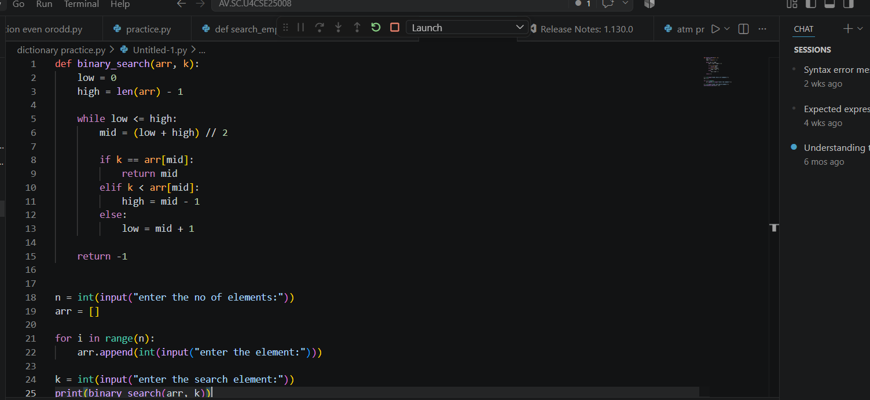
Output:
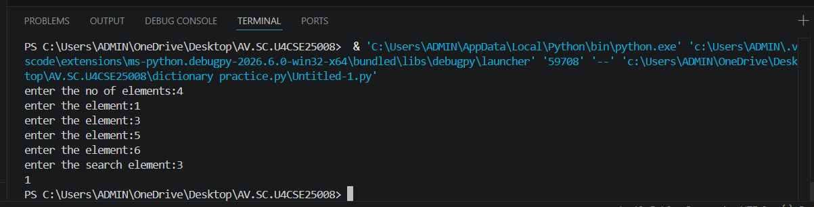
Explanation
Condition 1: k == arr[mid] — Element Found
- The function binary_search(arr, k) receives the array and the search element.
- low is initialized to 0, which represents the first index.
- high is initialized to len(arr)-1, which represents the last index.
- The while loop runs as long as low <= high.
- mid is calculated using:
mid = (low + high) // 2
- The middle element is compared with the search element k.
- If k == arr[mid], the element is found.
- The function returns the index mid and stops searching.
Condition 2: k < arr[mid] — Search Left Half
- If k is smaller than the middle element, the condition is True.
- This means the search element can only be present in the left half.
- Therefore:
high = mid - 1
- The right half is eliminated.
- The process continues with the remaining left half
Condition 3: k > arr[mid] — Search Right Half
- If k is greater than the middle element, the elif condition is False.
- The else block is executed.
- This means the search element can only be present in the right half.
- Therefore:
low = mid + 1
- The left half is eliminated.
- The process continues with the remaining right half.
Condition 4: low > high — Element Not Found
- The while loop continues until low <= high becomes False.
- When low > high, there are no elements left to search.
- This means the search element is not present in the array.
- The function returns -1.
Error table:
s.no | Error obtained | Rectification
 | Wrong index in binary search | Use high = mid - 1 for the left half and low = mid + 1 for the right half.
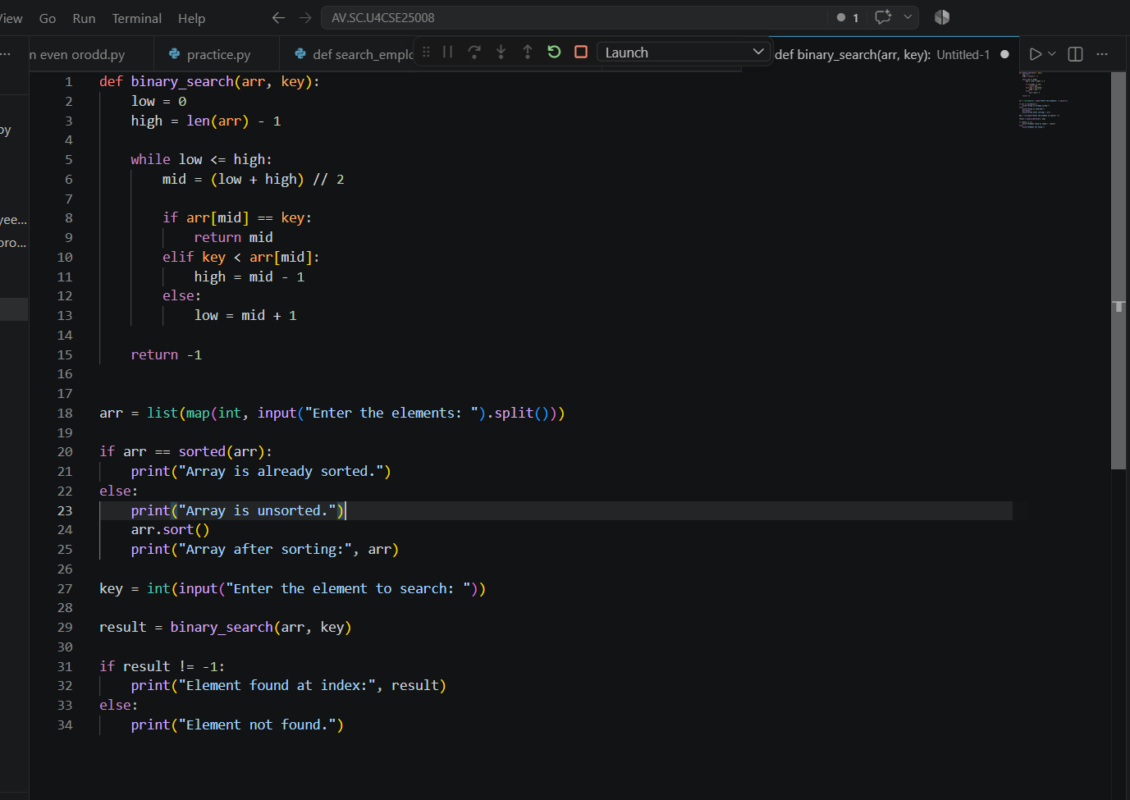
Output:
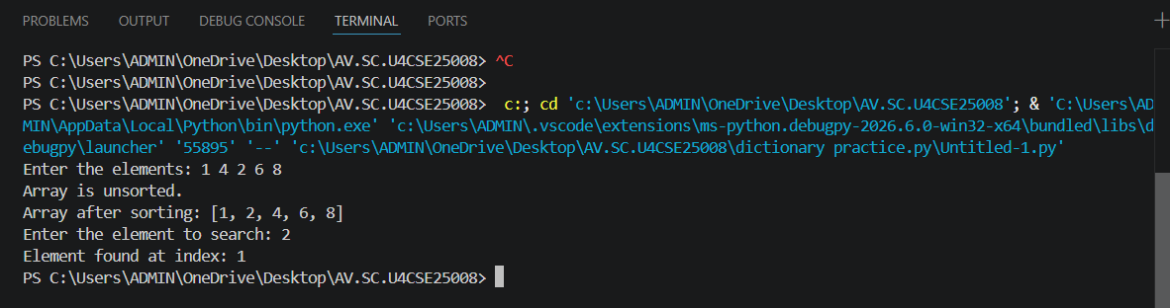
Explanation
Condition 1: arr[mid] == key — Element Found
- The function first calculates the middle index using mid = (low + high) // 2.
- It compares the middle element arr[mid] with the search element key.
- If arr[mid] == key, the condition is True.
- The element is found.
- The function returns the index mid.
- The search stops.
Condition 2: key < arr[mid] — Search Left Half
- If key is smaller than arr[mid], the condition is True.
- This means the required element may be present in the left half.
- The right half is ignored.
- high is changed to mid - 1.
- The search continues in the left half.
Condition 3: key > arr[mid] — Search Right Half
- If key is greater than arr[mid], the previous conditions are False.
- The element may be present in the right half.
- The left half is ignored.
- low is changed to mid + 1.
- The search continues in the right half.
Condition 4: low > high — Element Not Found
- The while low <= high loop continues until there are elements left to search.
- When low > high, the loop stops.
- This means the element is not present in the array.
- The function returns -1.
- The program prints "Element not found."
Condition 5: Array is Already Sorted
- The program checks whether the given array is already sorted.
- It uses:
arr == sorted(arr)
- If the condition is True, it prints:
"Array is already sorted."
- The array is directly used for binary search.
Condition 6: Array is Unsorted
- If arr == sorted(arr) is False, the array is unsorted.
- The program prints:
"Array is unsorted."
- It then uses arr.sort() to sort the array.
- The sorted array is displayed.
- Binary search is then performed on the sorted array.

Error table:
s.no | Error obtained | Rectification
1 | Binary search on unsorted array | sort the array first using arr.sort() or provide a sorted array.

